

UNIVERSITY OF PETROLEUM AND ENERGY STUDIES
DEHRADUN

CYBER THREAT INTELLIGENCE

LAB 9

Reporting Malicious Artifacts to CTI Community

MTECH-COMPUTER SCIENCE
ENGINEERING
CYBER SECURITY AND FORENSICS

Name: Jigesh Sheoran
SAP ID: 590025428

Objective — Learn to report Malicious Artifacts to CTI Community portals.

- Abuse IPDB
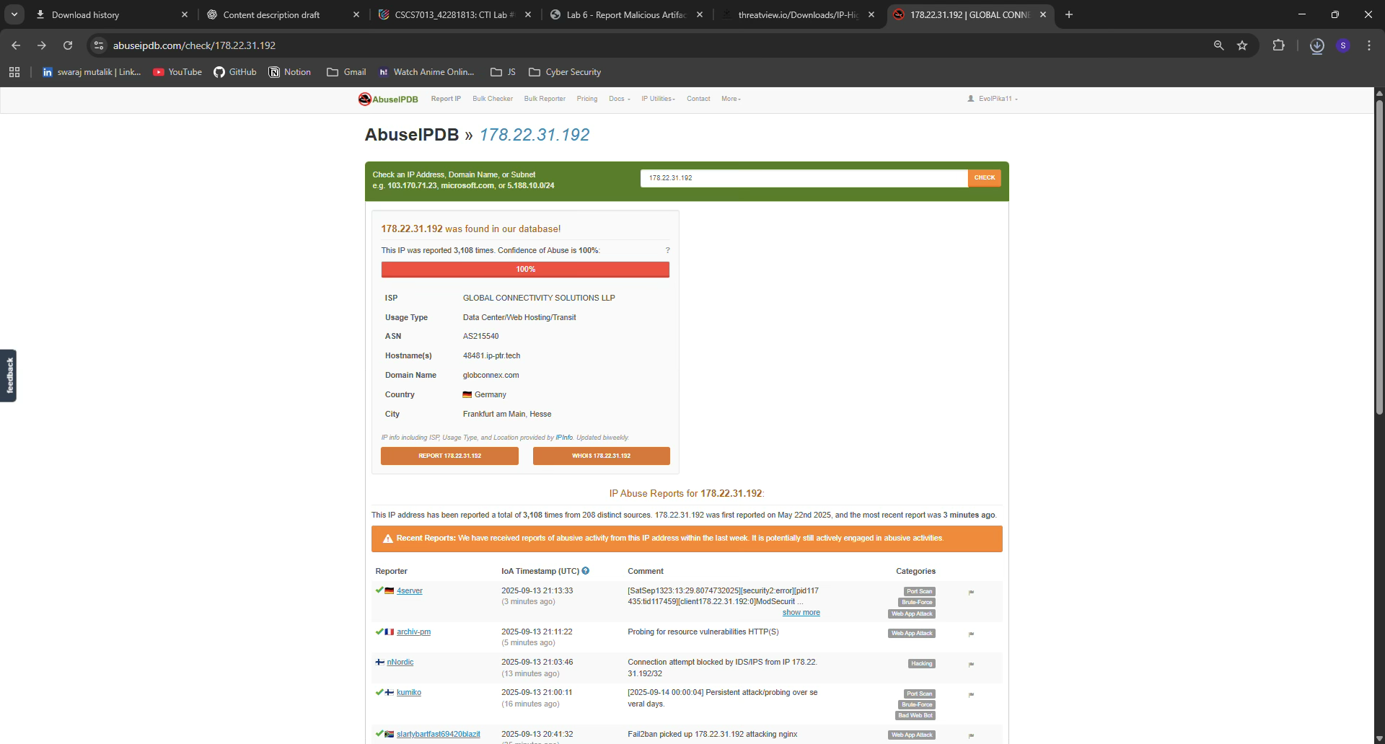
The Abuse IP Database shows that IP: 178.22.31.192 was found in their databse.

This IP was reported 3,108 times.
Confidence of Abuse is 100%.
Origin : Frankfurt, Germany
Type: Data Center, Web Hosting.
Domain: http://globconnex.com

- URL Haus
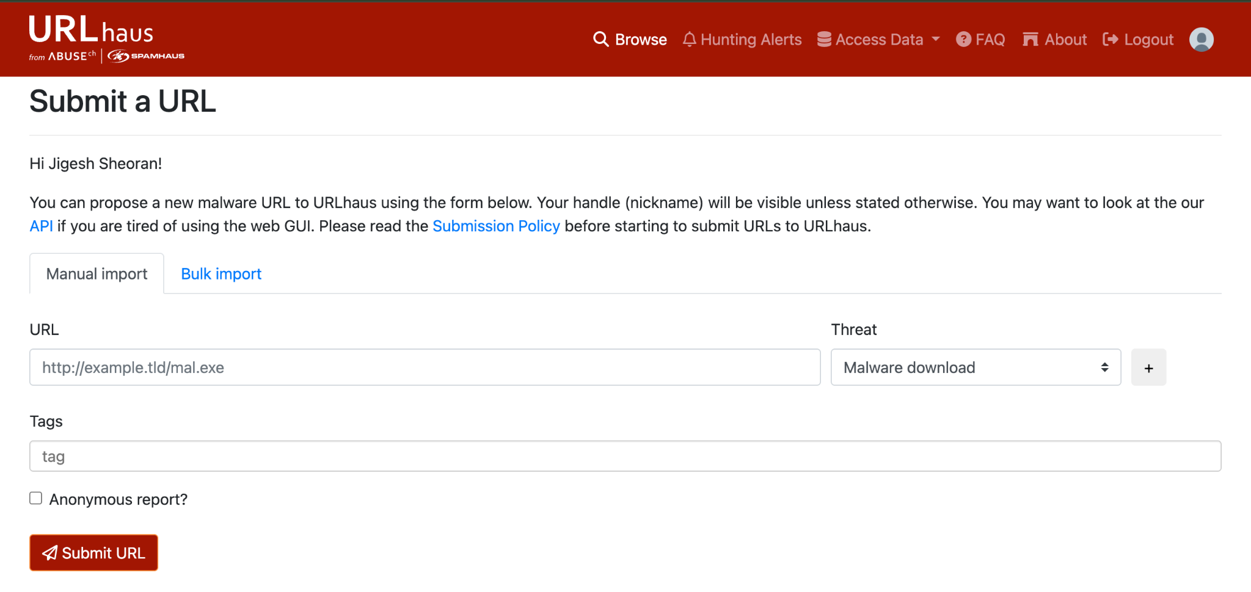
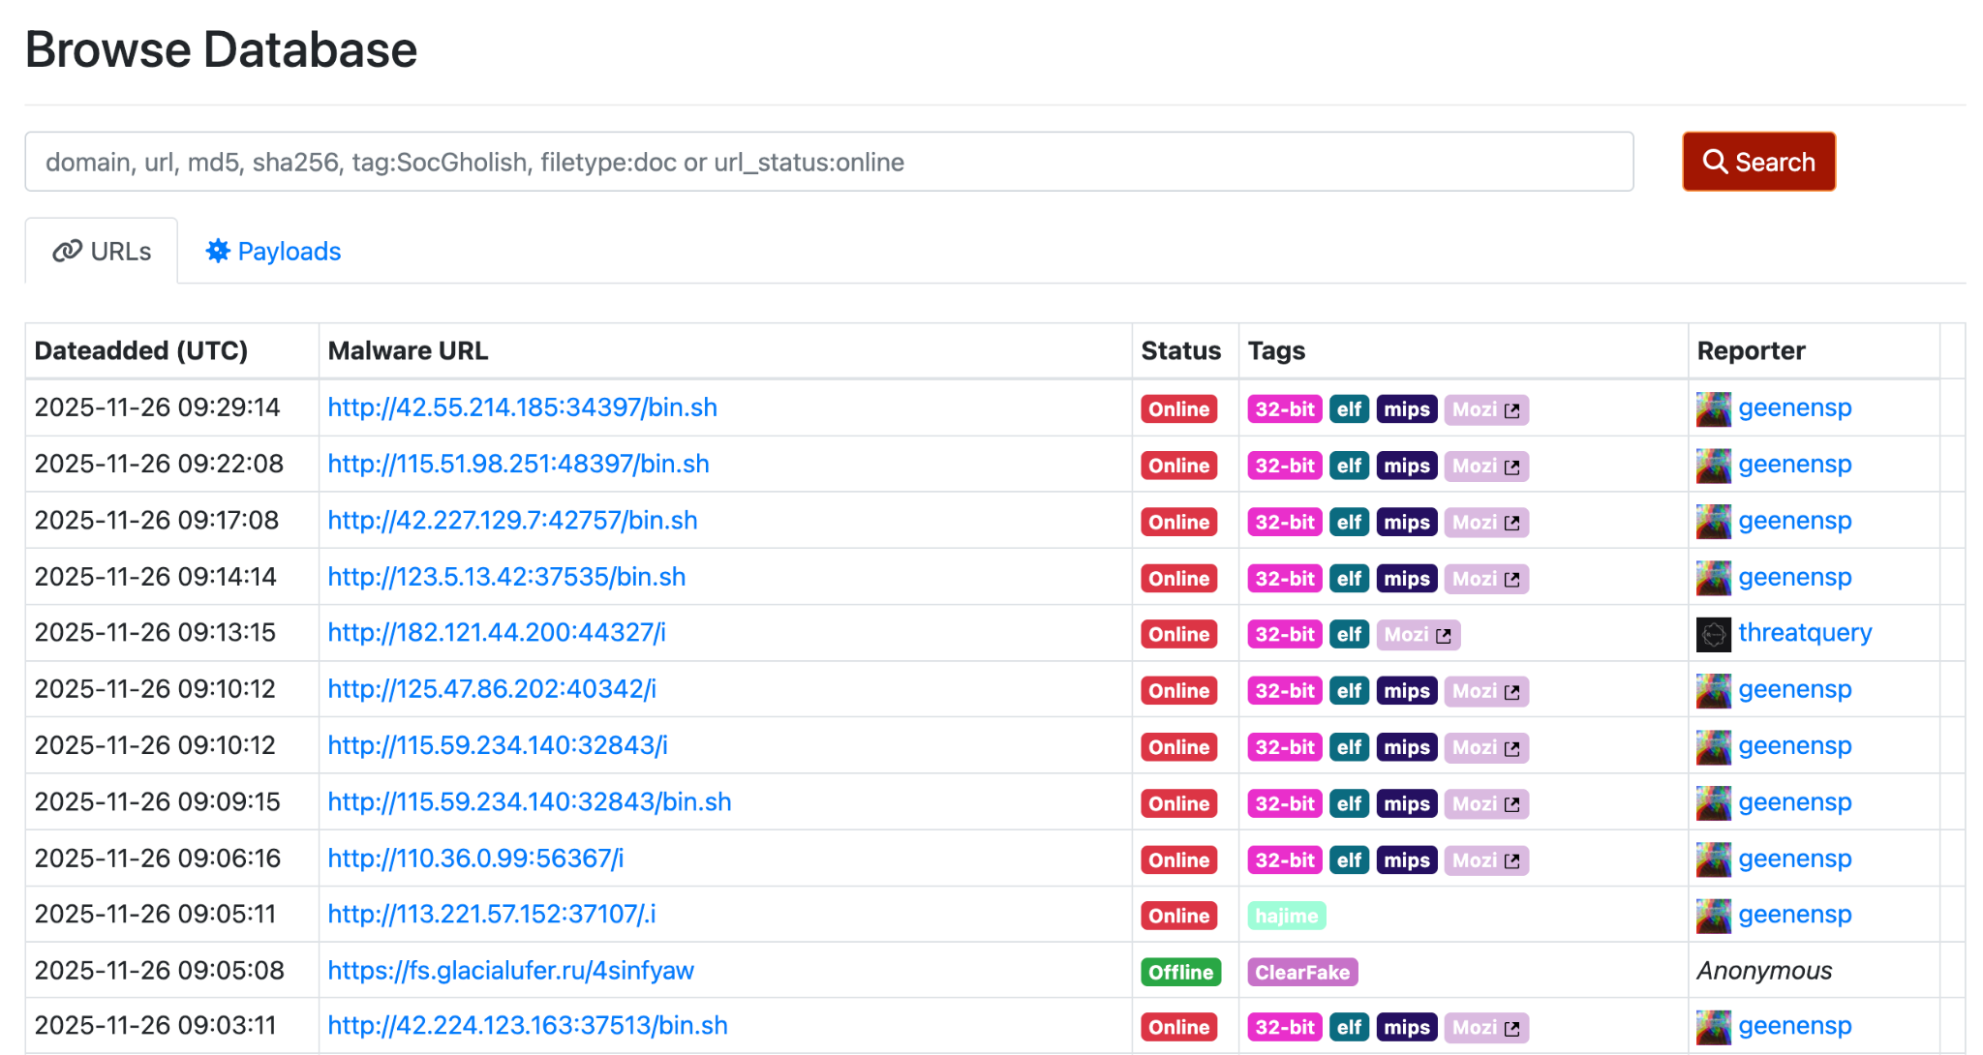
In URL Haus i submitted the IP: 143.20.64.235.
Report: Malicious
Date: 2025-09-11
Therefore this shows that the following IP is associated with malware distribution & SQL Injection making it a known malicious entry for CTI Platforms. But this current IP has already been reported so we don’t need to report it again.
Source for IP: https://github.com/duggytuxy/Data-Shield_IPv4_Blocklist
- Phish Tank
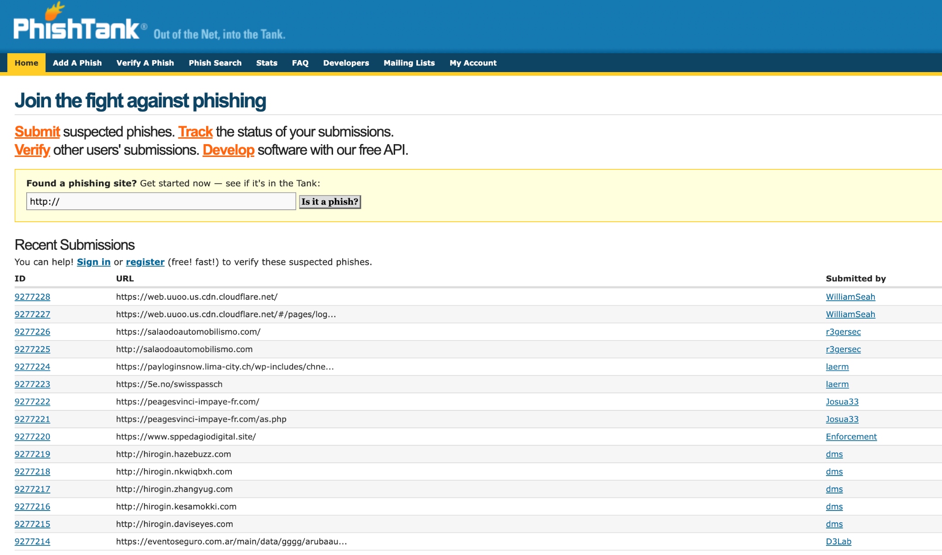
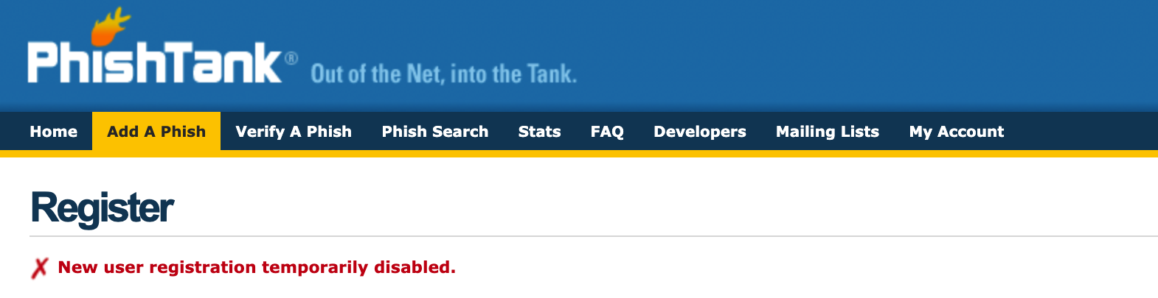

Could not Add / Report a new Phish because reporting requires being a registered user and new registration has been closed on PhishTank for quite some time.

- Blocklist.de
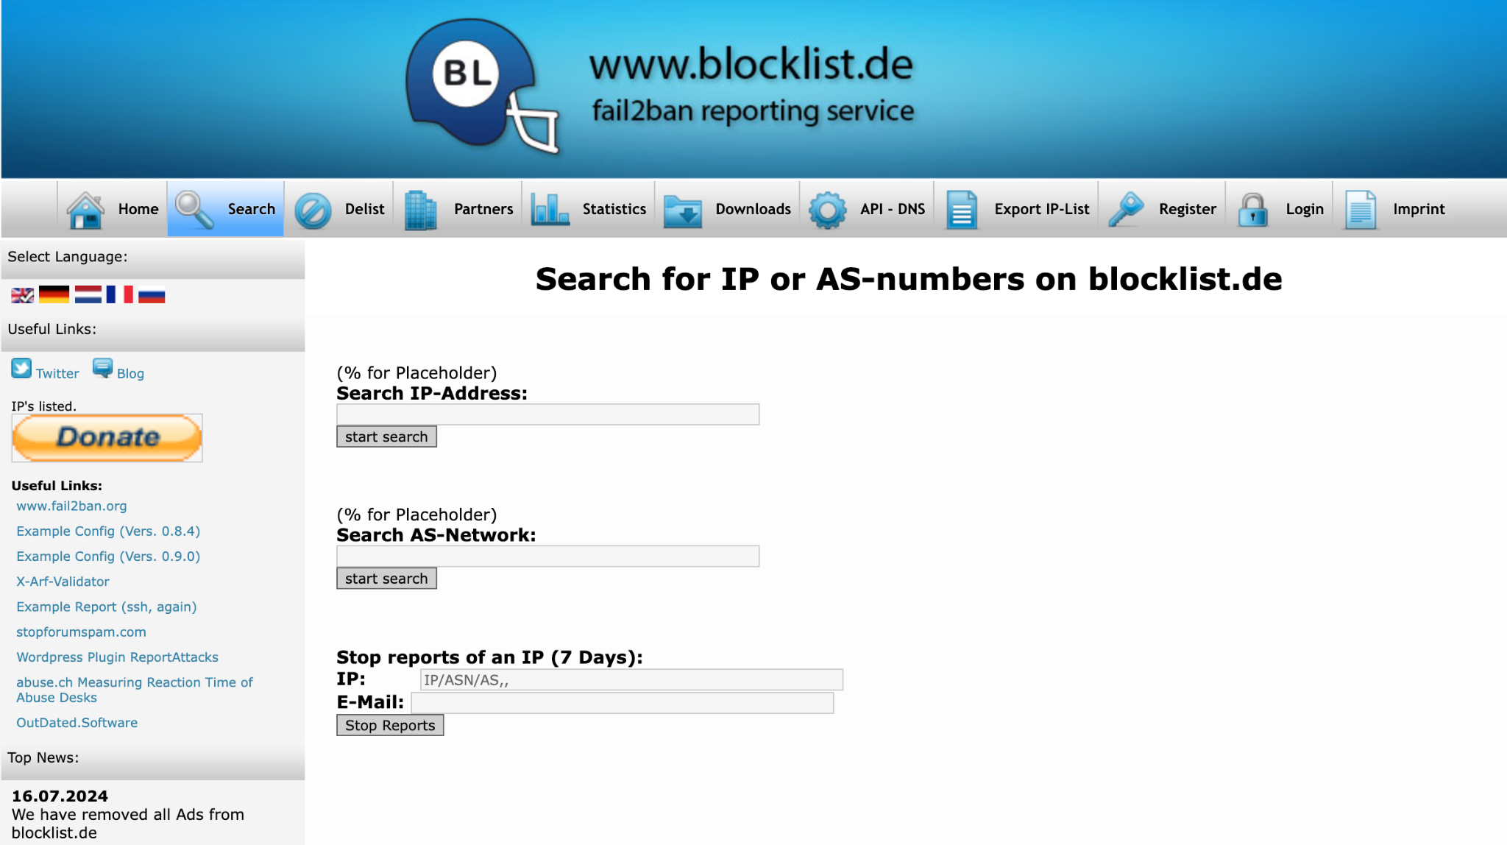
For this platform I choose a random IP address from https://threatview.io. But blocklist.de returned a video result.
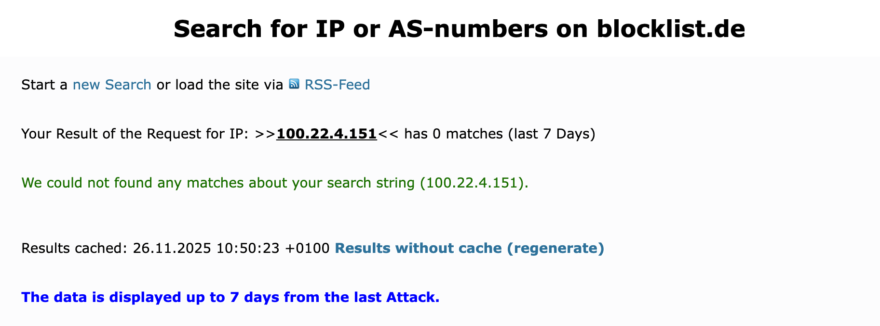
IP : 100.22.4.151
Report: 0 Matches in the last 7 Days.
Blocklist.de also provides graphical statistics of various attack types and the frequency of reports over a specific time period.

----------------------------------------------------END------------------------------------------------------

